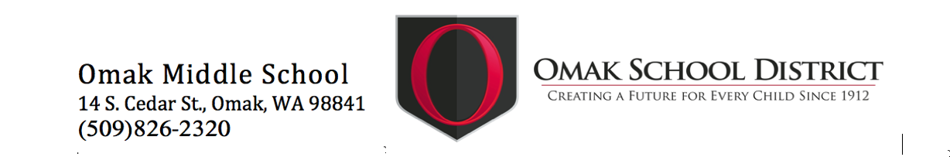
Omak Middle School
Weekly Bulletin

2/04/23 OMS Band Field Trip
2/08/23 Parent Team Committee – 5:30 PM OMS Library
2/10/23 No School – Professional Development Day
2/17/23 OMS Winter Formal Dance 7:00 PM
2/20/23 No School
2/28/23 School Board Meeting @ 5:30 PM
3/16/23 OMS Band Field Trip
3/17/23 No School – Professional Development Day
3/28/23 School Board Meeting @ 5:30 PM
3/29/23 Early Release Day – OMS @ 12:45 PM

OMS DAILY SCHEDULE

Monday 8:00 AM–2:00 PM ● Tuesday – Friday 8:00 AM–3:00 PM
● Early Release Days 8:00 AM – 12:45 PM

OMS WINTER FORMAL
DANCE
Attention Parents: OMS ASB will be hosting a winter formal dance with a Valentine's theme on Friday, February 17th from 7-9 p.m. There is no charge to enter the dance. Students are not allowed to leave the dance and re-enter. Also, students that bring a bag or backpack will need to check-in these items until the end of the dance. . .If you are interested in chaperoning at the dance, please contact Dr. Christoph at rchristoph@omaksd.org for pre-approval. For the safety of all students, parents that have not been pre-approved to chaperone will not be allowed to enter the building during the dance.

PARENT TEAM COMMITTEE

The Parent Team will be meeting Wednesday, February 8th, 2023 in the OMS Library at 5:30 PM. Please come join us!

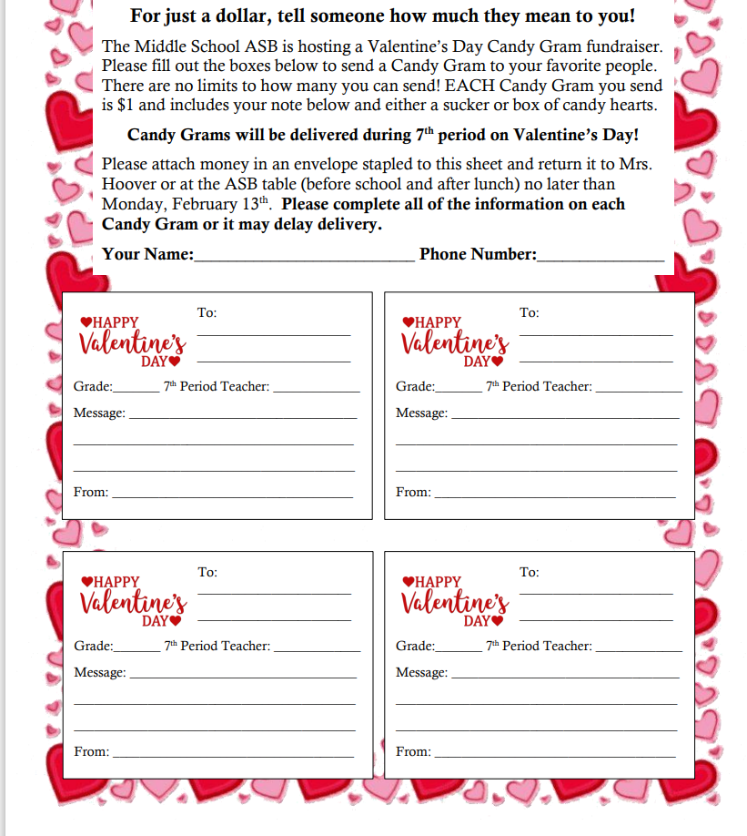
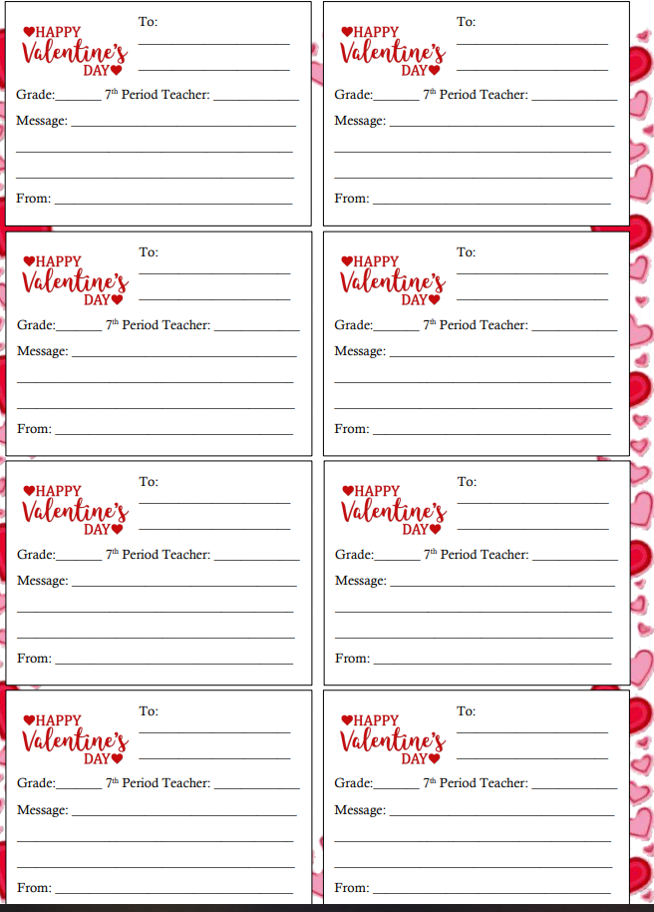

CLUB SHRED ANNOUNCEMENT

Club Shred Ski Bus is going to the Loup tomorrow, February 4th, 2023. Any questions please contact Club Shred advisor Mrs. Hunter at ahunter@omaksd.org.

Okanogan Valley Soccer Club

Let me take this opportunity to introduce you to the Okanogan Valley Soccer Club soccer teams. We are a newly established, U14 traveling soccer club that’s comprised of a boy and a girls team under North Central Youth Soccer Association. Our goal is to provide a higher level of instruction to strongly develop local players in their transition from youth to high school soccer in a healthy and supportive environment. If you are a soccer player born between January 1st 2009 and December 31st 2012 and would like to join or receive more info please grab an information signup page at the Middle School office or visit our Facebook page at NCenYSA U14 Soccer. We hope to see you out there playing

ATTN: PARENTS/GUARDIANS
OMS STEAM CLASS has some fun activities coming up!
The Teacher really is in need of donations of the following:
Soup Cans
Soda Cans
Cardboard boxes
Paper towel tubes
Toilet paper tubes
If you can send any of these items to school, please have your student drop them off at the office, thank you!

OMS CLUBS

STEM ADVISORY Club – Thursdays after school in Mr. Ruiz’s classroom
Ski Club – Saturdays, during January and February
CHESS Club – Tuesdays 3-4 PM in Ms. Beck’s classroom
NATIVE AMERICAN Club – Wednesdays 3-4 in Room 211
ASB Meetings every Wednesday at Lunch in Mrs. Hoover’s classroom

BUS INFORMATION

If there is a change in your student’s after school transportation plan it must be in writing. Please have your student bring a note to the school office at the start of school day so that we can get them a bus pass to ride, if different than your regular, a bus. The office can accept an email also sent to Omsnotes@omaksd.org, provided it is from parents/guardians listed in skyward.

OMS COMMUNICATION

We will communicate through the regular school mailings, as well as the following additional communication:
      - Skyward Family access
      - Parent/guardian emails, students on his/her school issued g-mail accounts
      - Omak School District web page and OSD Facebook page posts
      - Omak Middle School web page
      - OMS Bulletins and our School Messenger calling system

Please feel free to contact the school secretaries listed below for assistance.
If your call is not answered, please leave your voice mail message, and we will return your call.
OMS Secretaries – Office Hours 7:30 am – 3:30 pm
Main Office - OMS Building Secretary | Lori Coffell | 826-8321 | lcoffell@omaksd.org
Main Office - OMS Attendance Secretary | Gail Thompson | 826-8358 | gthompson@omaksd.org
Counselor’s Office – OMS Counselor’s Secretary | Elizabeth Campos | 826- 8303 | ecampos@omaksd.org
Athletic Office – AD Secretary | Wendy Hensarling | 826-8501 | whensarling@omaksd.org

NURSE INFORMATION
Medications, taken at school, both over the counter and prescribed, require a Medication Authorization form be completed by the health care provider and guardian. These forms can be printed off from our school web site, filled out and turned into or faxed into the school nurse Debra Lawrence (dlawrence@omaksd.org) or Heidi Petersen (hpetersen@omaksd.org).

ATTENTION ALL STUDENTS
Safe Schools Alert, a tip reporting service that allows students, staff, and parents to submit safety concerns to our administration four different ways:
Phone: 206.557.3622 Text: Text your tip to 206.557.3622 Email: 1687@alert1.us Web: http://1687.alert1.us Parents - You and your child can easily report tips on bullying, harassment, drugs, vandalism or any safety issue you're concerned about through SafeSchools Alert. Save the number in your phone so you can use it whenever you need. In case of an emergency, still call 911! Every tip SafeSchools Alert receives about Omak School District is immediately logged in the system and our administration is notified so that they can investigate and take appropriate action. And, tips may also be submitted anonymously if you prefer. Together, using Safe Schools Alert, we can make Omak School District a safer place to work and learn!

ASB CARDS
There is no charge for Omak Middle School ASB Cards this school year.
______________________________________________________________________________________
OMAK MIDDLE SCHOOL STAFF INFO:
Staff Meetings - Library - Tuesdays - 7:30 a.m.
BLLT Meetings – Library – every other Wednesday – 3:15 PM

Omak School District does not discriminate in any programs or activities on the basis of sex, race, creed, religion, color, national origin, age, veteran or military status, sexual orientation, gender expression or identity, disability, or the use of a trained dog guide or service animal and provides equal access to the Boy Scouts and other designated youth groups. The following employees have been designated to handle questions and complaints of alleged discrimination: Civil Rights Coordinator and Title IX Coordinator Brittney Richter, (509) 826-7687, brichter@omaksd.org and Section 504 Coordinator: John Holcomb, (509) 826-8342, johnholcomb@omaksd.org , P.O. Box 833, Omak, WA 98841.
El Distrito Escolar de Omak no discrimina en ningún programa o actividad por motivos de sexo, raza, credo, religión, color, nacionalidad, edad, estado militar o veterano, orientación sexual, expresión de género o identidad, incapacidad o el uso de un perro entrenado o un animal guía o de servicio, y proporciona el mismo acceso a los Boy Scouts y otros grupos de jóvenes que sean designados. Los siguientes empleados han sido designados para estar a cargo de preguntas y quejas de presunta discriminación: Coordinadora de Derechos Civiles y Coordinador del Título IX:Brittney Richter, (509) 826-7687, brichter@omaksd.org; y el Coordinador de la sección 504: John Holcomb, (509) 826-8342, johnholcomb@omaksd.org, P.O. Box 833, Omak, WA 98841.

